Rice, Rice Pudding (Richard)
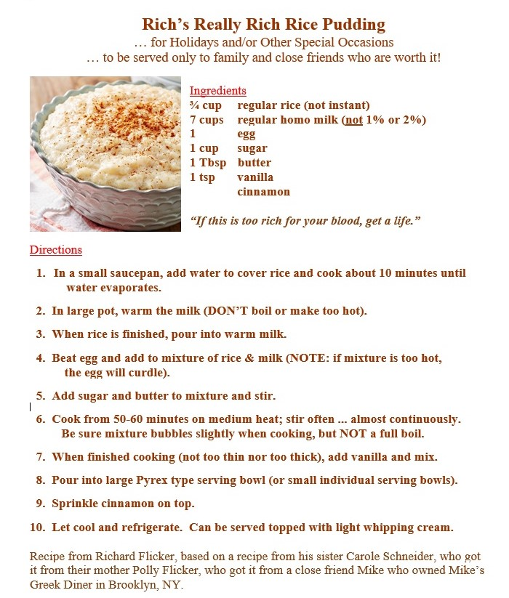
Bon Appetit

